Thomas Breakwell was a young Englishman who lived at the turn of the 19th century. He held an important position in a cotton mill in the southern United States and spent his vacations in Europe. On his way to Europe in the summer of 1901, he met a woman on a steamship and began talking with her about spiritual subjects. When they arrived in Paris, the woman took him along to meet a friend of hers who lived in an apartment in the city and who, she knew, had similar interests. The young woman welcomed them, and the three talked for some time. Before leaving, Breakwell asked his hostess whether he might return to speak further. He was invited to come back the next morning.

When he arrived, the young woman noticed that his eyes were shining brightly and his voice was full of emotion. She asked him to be seated. Breakwell looked at her intently for a moment, and then described for her a strange experience. After he had left her home the day before, he had walked along an avenue, alone, in the warm and heavy evening air. Not a leaf stirred around him. Then, all of a sudden, a great wind came up and he could hear in that wind a voice, sweet and powerful, speaking of the coming of a new message from God.

The young woman urged him to be calm. You see, she knew of the message to which Breakwell referred. During the next three days, over the course of many hours, she told him everything she could about the Bahá’í Faith—its history and its teachings—and about ‘Abdu’l-Bahá, the Perfect Exemplar of those teachings, who was living in the prison-city of ‘Akká, in the Holy Land.

By the end of three days, Breakwell’s heart was so filled with joy and hope that he wanted nothing other than to travel to ‘Akká and visit ‘Abdu’l-Bahá. It happened that there was another young man who had already made plans to go to the Holy Land for this very purpose and who was most pleased to have Breakwell accompany him. So, a message was sent to ‘Abdu’l-Bahá requesting permission for him to come and, in a short time, they were on their way.

"My Lord, I believe, forgive me. Thy servant Thomas Breakwell."

When the two men arrived at ‘Abdu’l-Bahá’s home, they were taken into a room where several other men were gathered. Looking around, Breakwell became deeply troubled. There was no one in the room to whom his heart was drawn, and thinking that ‘Abdu’l-Bahá must be among those present, he feared that he had failed to recognize that Heavenly Being about whom he learned in Paris. He sat down in despair. At that moment, a door opened, and Breakwell looked up. He saw there a brilliant light, from which the figure of ‘Abdu’l-Bahá emerged. He immediately knew that his dearest wish had been fulfilled.

Breakwell spent two glorious days in the presence of ‘Abdu’l-Bahá, during which the fire that had been enkindled in his heart grew stronger and stronger. When Breakwell told ‘Abdu’l-Bahá about his job at the cotton mill, where children were used as workers, ‘Abdu’l-Bahá advised him to resign from his post, which he did without hesitation. At the end of his visit, he returned to Paris, his spirit ablaze. He no longer had income from his well-paying position in the cotton mill, and he suffered greatly from illness. But these things did not dim his joy in the least. He burned like a bright candle, sharing his light with everyone he met until at last, overcome by his illness, he died. Upon his passing, ‘Abdu’l-Bahá revealed a Tablet in his honor, which includes the following verse: “O Breakwell, O my dear one! Thou hast lit a flame within the lamp of the Company on high, thou hast set foot in the Abhá Paradise, thou hast found a shelter in the shadow of the Blessed Tree, thou hast attained His meeting in the haven of Heaven.”

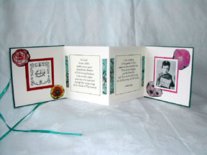
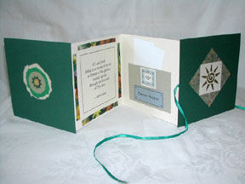
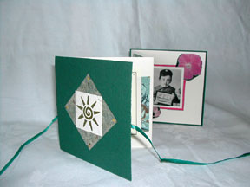

I was thinking it might be neat to make a little book about Thomas Breakwell like the ones regarding Shoghi Effendi above. Having a picture of Thomas Breakwell, the group picture, a picture of 'Abdu'l-Baha, Thomas Breakwells name nice and big on the cover, the quote from Thomas Breakwell declaring his faith, the reply from 'Abdu'l-Baha, the quote the children learn in the lesson. Will put up a picture when I give it a go :).

