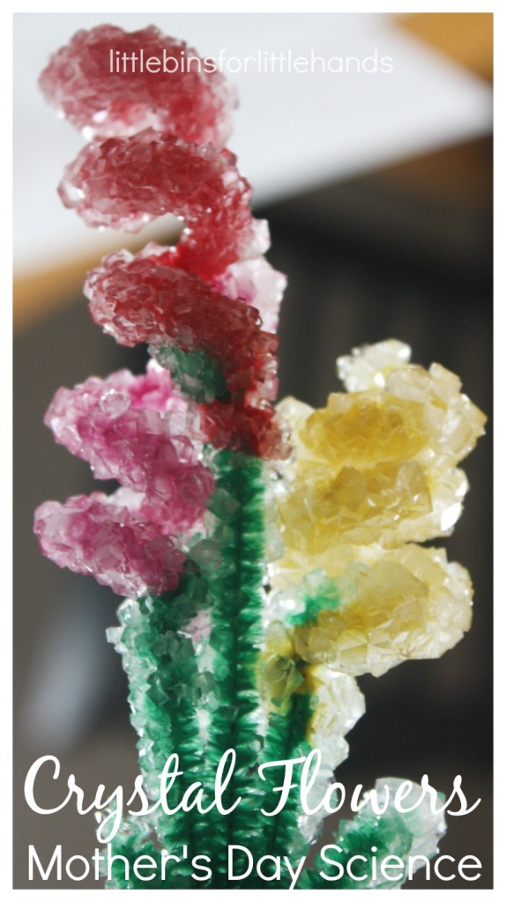

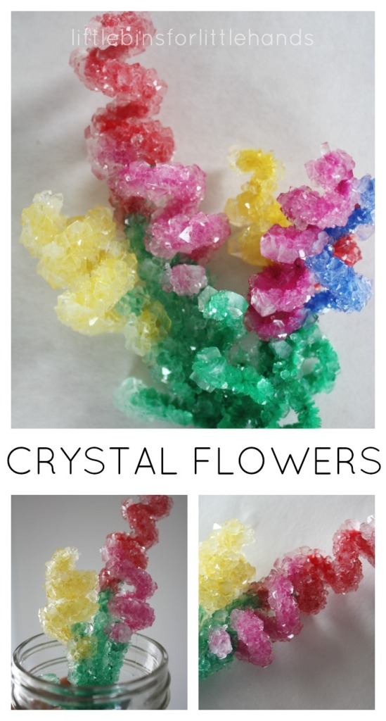

EASY CRYSTAL FLOWER BOUQUET SCIENCE EXPERIMENT
These fun crystal flower bouquets are so pretty for Spring science! Make sure to see our Crystal Rainbow and our Crystal Eggs!. Crystal growing is definitely a classic science experiment {check out all 25} that you must try with your kids! The set up is easy! I found the super simple recipe over at Happy Hooligans. make sure to visit her for all the details. Our crystal flower bouquet is perfect for any occasion!

CRYSTAL FLOWER SET UP
It’s fun to observe chemical reactions with kids! Make sure to check the recipe over at Happy Hooligans for exact measurements and mixing procedure {super easy and quick} for your crystal hearts. Since you are dealing with hot water, my son watched the process while I measured the solution and stirred. An older child might be able to help a little more!

SUPPLIES NEEDED:
- Borax {found with laundry detergent}
- Water
- Jars or vases
- Pipe Cleaners
- Stick, Spoon, Dowel
Crystal flower science is pretty cool! It’s all about suspension of molecules, but this is beyond us right now. Get the full science information from Steve Spangler. It’s pretty neat!
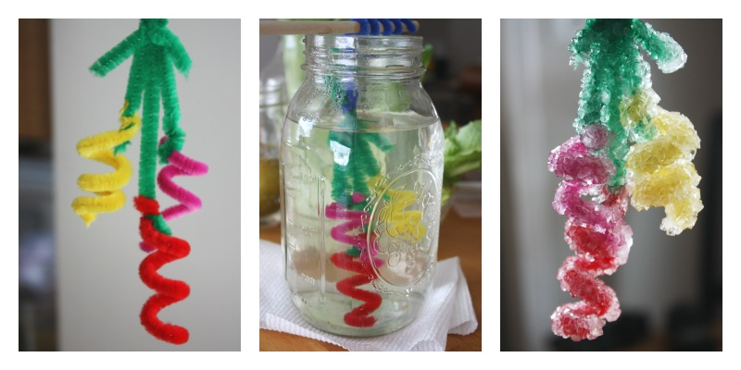

BRIGHTLY COLORED PIPE CLEANERS MAKE BEAUTIFUL CRYSTAL FLOWER BOUQUETS
To make the crystal flower bouquets, I simply twisted pipe cleaners around pencils to get coiled “flowers”. Be as creative as you want. I bundled a few pipe cleaner flowers together. I attached a green pipe cleaner stem and then used the end to wind around a dowel. This way I could suspend the flowers in the jar without them touching the bottom.
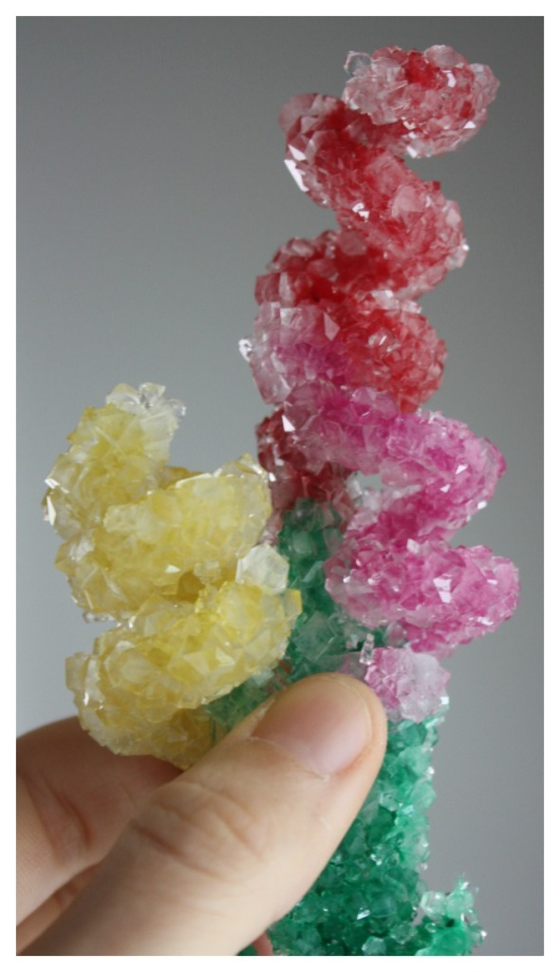
We left our crystal flower bouquets in the borax solution overnight. When we got up in the morning, we had beautiful, bright crystal flowers! We put our crystal flower bouquets in a mason jar. The crystal flowers sparkle on the kitchen table with the sun shining in on them!

